## Intro

Course: Mobile Applications in IOS

Team: Nupur Maheshwari and Mohona Sengupta

Role: UX Designer / Swift Engineer

Objectives:

* Learn fundamentals of Swift programming
* Apply user research skillset to create a marketable application
* Build out the application interface and design
* Build the application, user test, iterate

## Sprint 1: Ideation

All we were told was simply: “create an application”. We knew it had to answer a specific pain point, be attractive to some user, be complicated in some way, but Nupur and I had no other guidelines. We sat down together and went through our days, listing out moments that we felt would be better guided by a mobile application. Our ideas were vast and sometimes pretty crazy, but we landed on a few solid ideas. From there, we did some rapid user testing via Google Forms, asking people how necessary these ideas really were, and our findings helped us finally choose Outrun.

## Outrun is an application to motivate users to focus on having fun outdoors. Outrun asks the user for some preferences and then maps out a route to those specifications. Then the application guides the user through the walk while playing the game itself. Specifically, a “zombie apocalypse” game set in Pittsburgh, where the user must “slash”, “duck”, and “tap” different items placed in an AR environment to survive the end of days. You can find our complete write up here:

## Sprint 2: UX

## Low Fidelity Wireframes

Our second deliverable was focused on the front end of our application. We first created a series of low fidelity wireframes, trying to focus on core functionality and the best way to guide the user through this application without having to explain every single step.

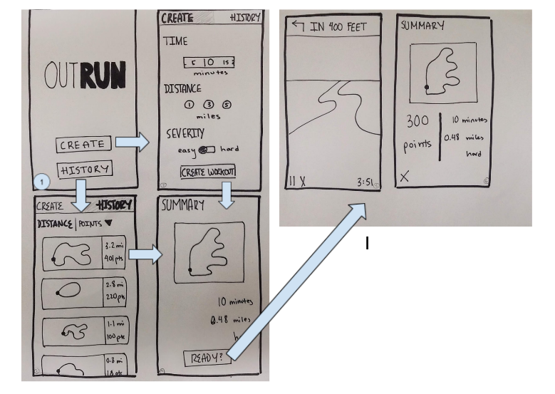In our wireframes, you can see: the splash screen, a create page where the user can create a new route, a history page where a returning user can quickly choose from their past routes, a summary page that either shows a new or old route, the game itself through the camera and overlaid directions, and finally a new summary card with points and stats added in.

## User Research

Our application is a very kinetic game, so we cut out every screens and actually pasted them to a piece of cardboard. We then asked our interviewees to literally move through the application while holding their “phone”, and run around pretending to see the zombies through their camera during the game portion of the application.

Main feedback:

* Overall, users were responsive and interested in our application idea
* CREATE SCREEN: Choosing both a time and distance makes no sense. Allow the user to choose on or the other.
* GAME SCREEN: Include a minimap of the total route
* SUMMARY PAGE: include interesting and relevant stats like total points, birds avoided, zombies killed
* GENERAL: What is the true value of the points? Create some motivation behind it rather than just “aim high”

## High Fidelity Wireframes

<https://www.figma.com/file/L1AzHppJmJcYofhQtraZYQ/OutRun?node-id=0%3A1>

Our changes.

* CREATE SCREEN: We automatically select either time or duration
* GAME SCREEN: Minimap and better “quit”, “pause” buttons
* SUMMARY SCREEN: a graph of previous points to create a sense of competition (to beat yourself), and watch your progress.
* INFO SCREEN: To better explain the game and the thought process behind it
* Potential “version 2”: Allow users to buy “items” from a store with their points: shields, weapons, fun upgrades, and even tangible merchandise from fitness companies.
* Potential “version 2”: leaderboards and Apple Games “achievements”.

## Sprint 3: API

We knew that we had to rely on external API and libraries in order to really bring this game to life. In particular: Google Places API, Google Maps API, and the RealityKit extension that Apple provides. In terms of heavy programming, the densest parts of Outrun are: 1) the route creation and guidance and 2) the AR game itself. For this deliverable, we created a quick Swift file proving that we could satisfactorily access both the Places API and the Maps API, and use the information provided. You can read the full report here:

## Sprint 4: Version 1

Finally, with our user experience locked in and some experience in the API, we began work on the actual application itself. We are still building out Outrun with an expected deliverable date of 11/9, where we will have a Version 1 with the following features. Follow along with our progress on our public github at:

V1

* The User can input a distance and severity, and Outrun will create a route for their walk **COMPLETE**
* During the walk: AR vision in the camera to see three game features: zombie bird, zombie human, and first aid kit
* During the walk: Outrun will give user directions on where to go **COMPLETE**
* During the walk: Ability to gain or lose points through phone hardware
* After the walk: Ability to see birds/zombies killed at the end
* After the walk: Ability to see final points in the end
* Information section **COMPLETE**
* TENTATIVE: The User can input a number of minutes and severity, and Outrun will create a route for their walk
* TENTATIVE: Ability to see past routes and select those
* TENTATIVE: See the final points along with graph of points achieved every time you took the route

## Future

After 11/9, we will have one week to beta test our complete application. With those findings, we will deliver a final Version 2 for consideration in a class-wide competition hosted by the Capital One Technology Group